|  |  |  |  |  |  |
| --- | --- | --- | --- | --- | --- |
| Mata Kuliah | : | Sinyal dan Sistem | Waktu | : | 120 Menit |
| Kredit | : | 3 sks | Hari/Tanggal | : | Senin / 14-04-2021 |
| Nama Dosen | : | Mifta Nur Farid, S.T., M.T.  Risty Jayanti Yuniar, ST., M.T. | Sifat | : | Open book |

1. Use the Fourier series analysis equation to calculate the coefficients ak for the continuous-time periodic signal.

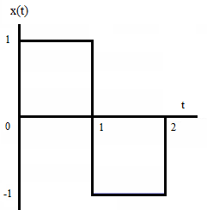

Score: 40

1. The input and the output of a stable and causal LTI system are related by the differential equation

$\frac{d^{2}y(t)}{{dt}^{2}}$*+ 6 $\frac{dy(t)}{dt}$ + 8 y(t)= 2x(t)*

1. Find the impulse response *h(t)* of this system.
2. What is the response *y(t)* of this system if *x(t)= t $e^{-2t}$ u(t).*

Score: 60

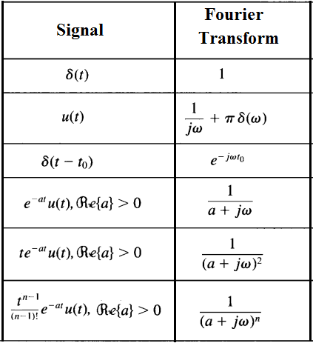

*------- “” Life is like riding a bicyle. To keep your balance, you must keep moving*

*– Albert Einstein------*